Unit Repossession – Repo Units

- Purpose

The product details for Repo Units are automatically created once the Closure and Valuation record have been approved. As of this writing, the staff can still add new Repo Units without going through the Closure and Valuation form.

- Views
  - List View
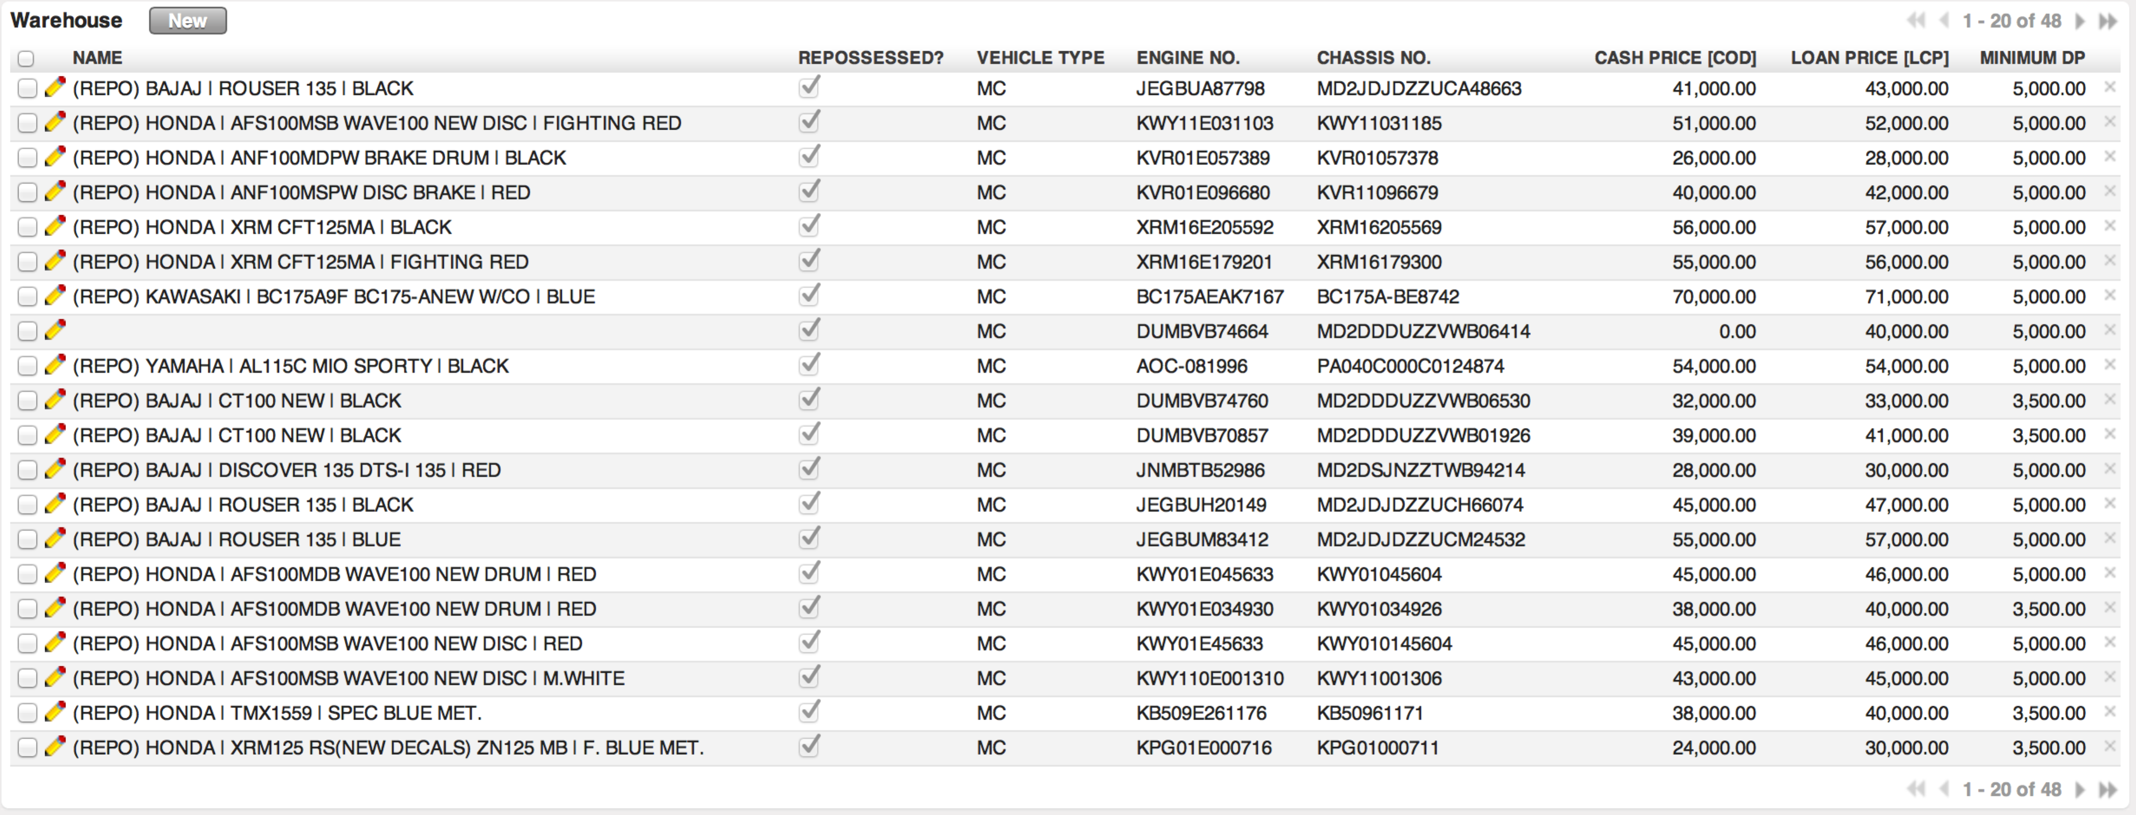
Figure 1. List view of Repo Units

  - Form View
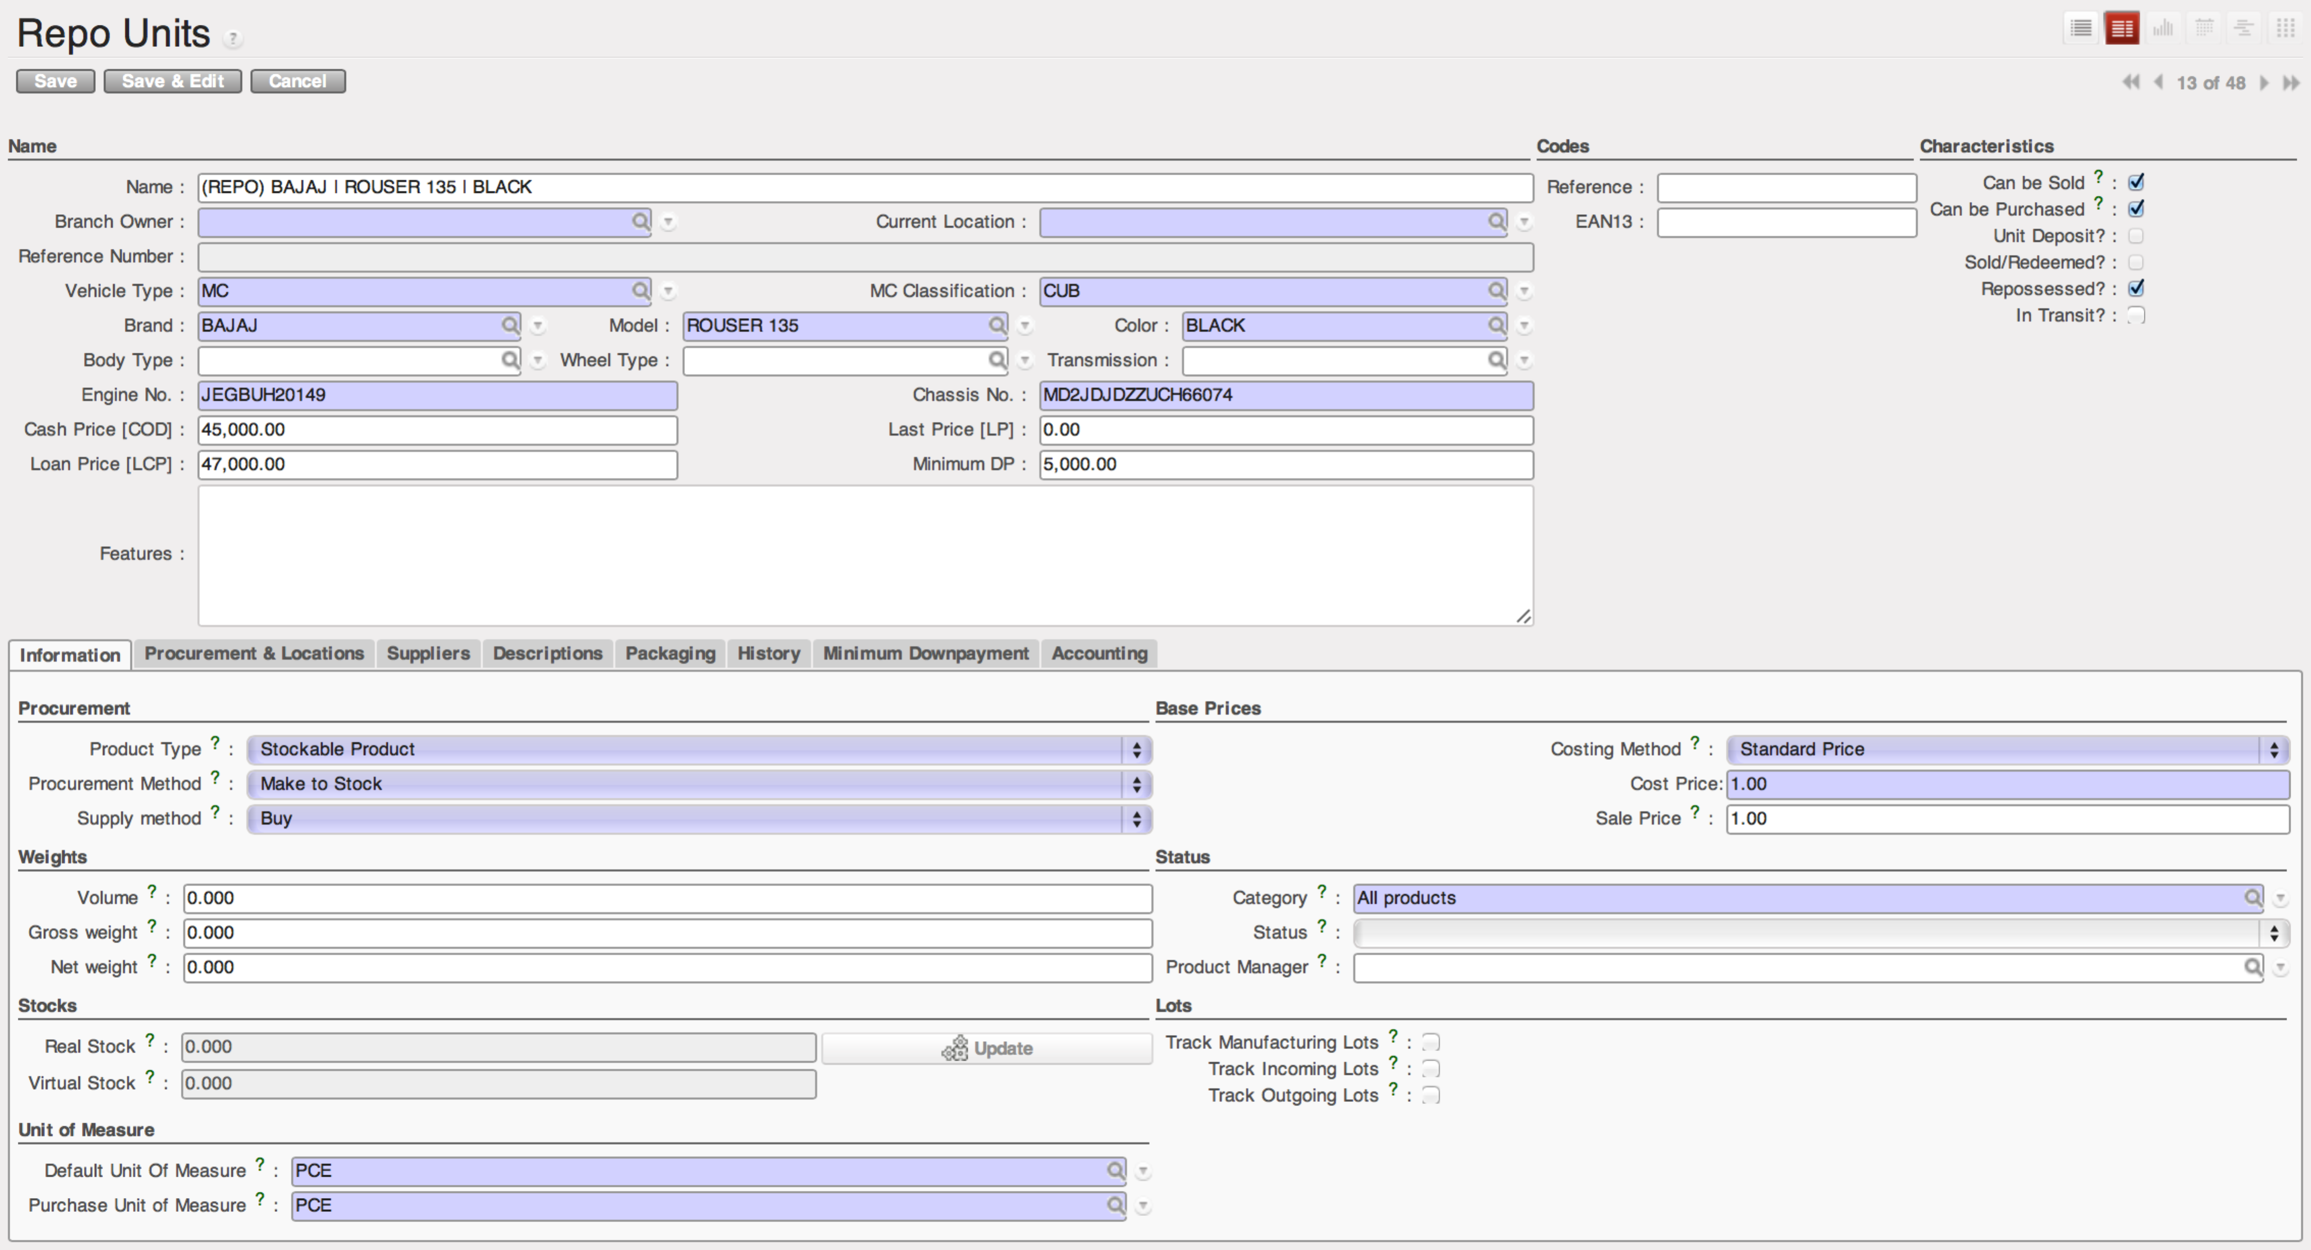
Figure 2. Form view of Repo Units

- Menu and Access Rights
  - Menu – Warehouse > MC Units > Repo Units
  - Access Rights
Role | Read | Write | Create | Delete
Product Pricing-In-Charge | Yes | Yes | Yes | No
CI/Collector | Yes | No | No | No
Receptionist | Yes | No | No | No
Branch Manager | Yes | No | No | No

- Required Fields
All required fields can be easily distinguished from the form view. These are the fields highlighted in Figure 2.

- Vehicle Type – either ‘MC’ or ‘CAB’
- MC Classification – specifies the breaking period and the basis of 1st due date
- Brand – brand name of MC unit
- Model – model name of MC unit
- Color – color of MC unit
- Engine No. – this is a unique identifier
- Chassis No. – this is a unique identifier
- Repossessed – this field should be checked
- Product Type – set to ‘Consumable’
- The following the required fields should be left as is: Procurement Method, Supply Method, Costing Method, Cost Price, Sale Price, Category, Default Unit of Measure and Purchase Unit of Measure.

- Workflow
No workflow is defined for this submodule.

- User Action
No user action is defined for this submodule.

- Field Visibility
All fields are visible to all users with read access to the record.

- Reports and Print Outs
No print outs or reports define for this submodule.

